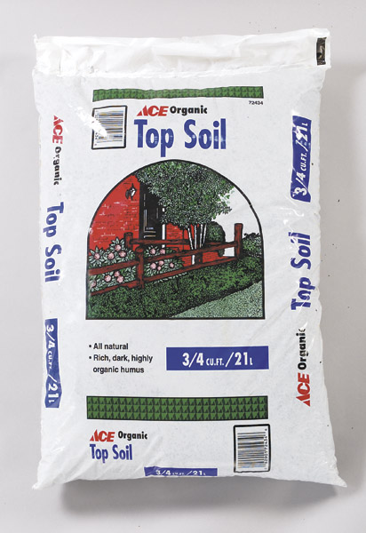
Ace Topsoil®

- 1 Cubic Foot Coverage
- Rich and dark topsoil
#14
- Ideal for top dressing

$2.49
7204076

